ASSIGNMENT - 6(b)

1. Create a class Vehicle and encapsulate the data members.

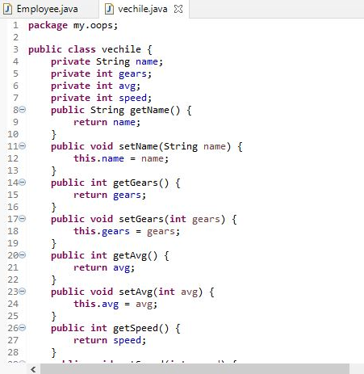

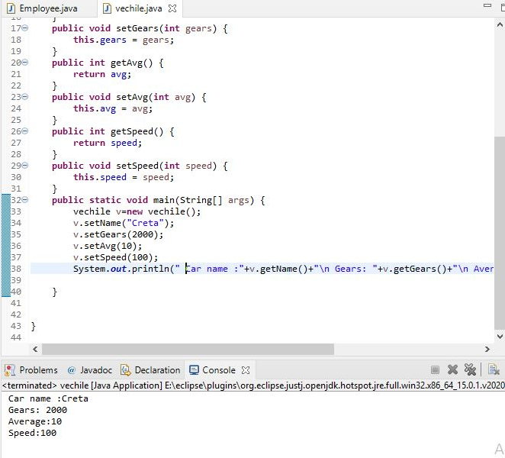

1. Create demo applications to illustrate different types of inheritance.

🡺Single Inheritance

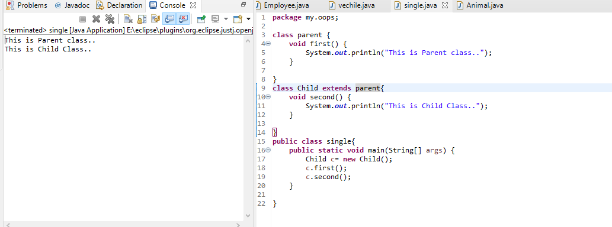

🡺Multilevel inheritance

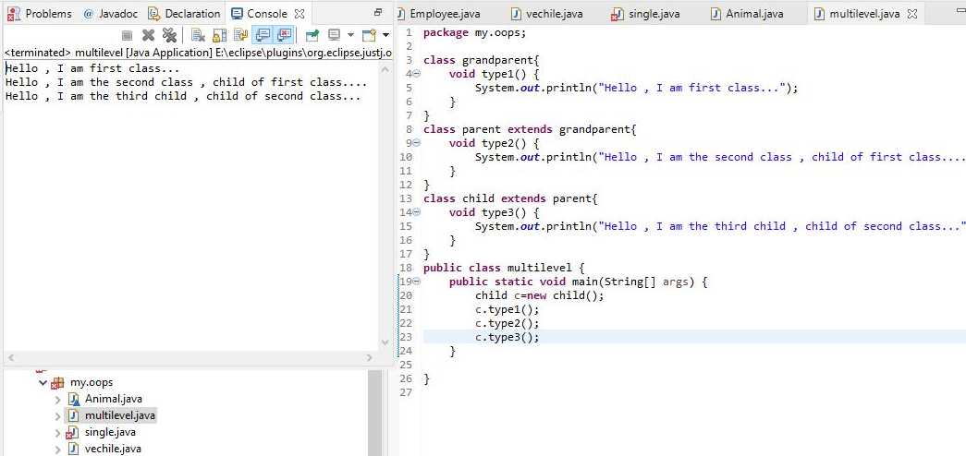

## 🡺 Hierarchical Inheritance

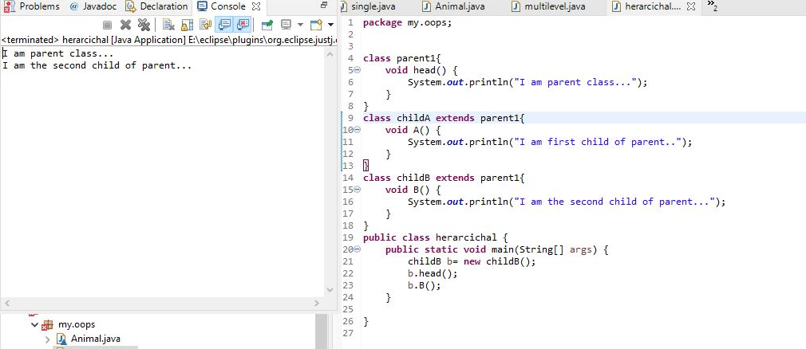

3.Create one Animal class(superclass), Dog class(subclass) the same method in the subclass override the method in the superclass.



